Abstract
VisCalcML – Machine Learning Viscosity Prediction to Enable Discovery of Base Oils for Lubricants

Hydrocarbon lubricants are critical for ensuring the longevity of equipment in a diverse range of industries including transportation, energy, construction, and aerospace. Novel base oils could lead to lubricant formulations with superior properties such as enhanced long-term stability and a more consistent kinematic viscosity (KV) over a range of temperatures. However, development of novel base oils is hindered by the significant amounts of time and effort required for synthesis and purification before obtaining empirical KV-temperature data. Machine learning-based approaches can enable facile screening and discovery of base oil molecules with attractive rheological properties. Here, we train 16 machine learning models on a dataset of 1356 KV-temperature measurements from 399 unique hydrocarbon molecules. Bayesian optimization with nested cross-validation is implemented for model optimization and top model selection. Our best-performing model predicted KV on a test set of 12 unseen poly alpha olefins (PAOs) with an R² of 0.989 and a root mean squared error of 0.997 mPa*s. We compare the performance of our best model to that of 2 other models from the literature. Our best model is then used to predict KV at 5 different temperatures (20 °C, 40 °C, 60 °C, 80 °C, and 100 °C) for 1000 hydrocarbon molecules generated through enumeration to screen for attractive lubricant molecules. We identify candidate molecules predicted to have favorable KV-temperature curves for future synthesis and characterization.

Outline
Topics are highlighted by initial writing responsibility: Patrick or Sibo
- Intro
  - Base oils (mineral oil, PAO, group V)
  - Desire to predict viscosity using ML
  - Previous methods
    - Group Contribution Methods
    - Cosmotherm
    - Goussard used
    - Panwar used ML on MD descriptors, trained on the API Project XY dataset
- Method
  - Training set – API Project XY
    - Target: KV as a function of T
    - Some
  - Features
    - Descriptors
    - 3D structure + descriptors
    - Molecular fingerprints
- Results
  - Various metrics of how well the model trained on the training set
  - Test set comprised of PAO-like molecules with experimental KVs
    - Great R^2 and RMSE, KV predicted vs actual
    - Note that chiral fingerprints as implemented do not result in different predictions for diastereomers
    - Comparison with results from Cosmotherm, Goussard, and Panwar
    - VI, calculated vs actual – there is room for improvement in part because the piecewise formula to calculate VI is highly sensitive to small changes in KV100.
  - Predicted KVs for various C30-ish hydrocarbon isomers
    - Number of possible isomers? Try https://structuregenerator.github.io/
    - Molgen 5.0: 1000 first isomers (mono- and di-branched alkanes)—any trends?
    - Expert-generated collection of C30ish molecules.
      - Does stereochemistry of mPAO matter?
      - Does regiochemistry of mPAO matter?
      - What about isomers with cyclic C6 or C5 core?
      - What about isomers with benzene core?
- Conclusion

Manuscript
- Introduction
Lubricants are critical for ensuring the performance and longevity of equipment in industries such as transportation, energy, construction, and aerospace. Advancements in these fields motivate on-going research and development of lubricants. For instance, recent hybrid electric vehicles use smaller engines that typically run less frequently but hotter for short periods of time, compared to traditional large-displacement internal combustion engine vehicles. Thus lubricants with lower viscosity and lower volatility, seemingly contradictory properties, need to be developed. Many applications also are trending toward less frequent (or entirely eliminated) fluid changes. To meet such challenges, lubricants are increasingly formulated with synthetic oil base stocks such as polyalphaolefins (PAOs). As a result of their molecular structure, PAOs (designed by the American Petroleum Institute as Group IV base oils) exhibit higher thermal stability, longer service life, and more consistent fluidity and kinematic viscosity (KV) across a range of temperatures than mineral oil base stocks (API Groups I-III base oils).
The effect of molecular structure on viscosity has been a long-researched topic.¹ Conventional PAOs (c-PAOs) are produced via Lewis-acid catalyzed oligomerization of linear alpha olefins (LAOs), primarily 1-decene, which is accompanied by unintentional skeletal isomerization—primarily methyl migration but also other processes such as formation of alicyclic structures—resulting in a wide distribution of chemical structures.{ Onopchenko, 1983 #431; Kapur, 1998 #407}{Azizov, 2010 #430} To produce more uniform molecular structures with less branching, metallocene catalysts have been utilized to oligomerize LAOs with head-to-tail regioselectivity and no skeletal isomerization side-reactions. The mixture is hydrogenated to impart chemical stability and distilled into various viscosity grades to produce metallocene-PAOs (m-PAOs), which possess higher VI than equivalent molecular weight c-PAOs.³ Additionally, due to the reduced number of tertiary hydrogen atoms, m-PAOs have increased oxidative stability compared to c-PAOs and mineral oils.
Hydrogenated PAO 1-decene trimers are the major component of PAO-4, a leading synthetic base oil. However, the chemical formula C₃₀H₆₂ has 182896187256 possible isomers,⁴ and it is improbable that m-PAOs are the best isomer in terms of viscometrics. Experimental synthesis and KV-temperature characterization of even a millionth of that chemical space is not feasible. Significant advances in molecular dynamics (MD)-based computational methods to predict viscosity have been developed by many, {Padilla, 1991 #421;Cui, 1996 #424;Cui, 1998 #425;Martin, 1999 #422;Chang, 2004 #423;Tartaglino, 2006 #420;Liu, 2015 #419;Panwar, 2023 #384;Kajita, 2020 #390;Nieto-Draghi, 2015 #433}{Goussard, 2020 #432} but such calculations still face challenges in accuracy, signal-to-noise, and computational efficiency. Even with recent methods that couple machine learning (ML) with molecular dynamics data,^{5h,i} computational feasibility for large-scale screening is limited. At an optimistic rate of 1 molecule per hour, a molecular dynamics-based viscosity prediction method would take over 20 years to analyze a millionth of the C₃₀H₆₂ chemical space.
Many non-MD kinematic viscosity prediction methods require empirical knowledge of physical properties of the oil compound such as density, entropy, enthalpy, or compressibility factor.⁶ For virtual screening of novel oil compounds, methods that do not depend on molecule-specific thermodynamic data are necessary. COSMOTherm has developed leading QSPR models for predicting density and dynamic viscosity over a wide chemical space, but such models require computationally expensive quantum mechanical geometry optimization and calculation of surface charge profiles.[refs] Non-MD machine learning methods to predict viscosity have been developed for various fields such as biofuels,⁷ ionic liquids,⁸ Lennard-Jones fluids,⁹ and lighter alkanes up to C20.¹⁰ Related to the hydrocarbon base oil field, Panwar and coworkers developed regression-based models trained on heavy hydrocarbons (C₈ to C₅₀),^{5h} using viscosity and density data from API Research Project 42.{Institute, 1967 #434} Although their top model utilized MD-derived dynamic descriptors, they also developed a model using exclusively static descriptors, which were generated quickly using PaDEL open-source software.¹¹ Their models require use of commercial MATLAB software and the Statistics and Machine Learning Toolbox add-on module.
Herein, we develop a machine learning model to predict viscosity of heavy hydrocarbons across a range of temperatures (Figure 1). First 16 machine learning models are trained on a dataset of 1375 empirical KV-temperature measurements from 394 unique hydrocarbon molecules. Bayesian optimization with nested cross-validation is implemented for model optimization and top model selection. On an unseen test set of 24 KV-temperature measurements from 12 unique PAO-like molecules, the top model performs favorably compared to existing viscosity prediction methods. The top model is then applied to (1) a set of randomly selected C₃₀H₆₂ isomers comprising 10% of the C₃₀H₆₂ constitutional isomer space, and (2) an expert-curated set of similar molecules in order to identify candidate molecules with favorable KV-temperature curves for future experimental synthesis and base oil characterization.
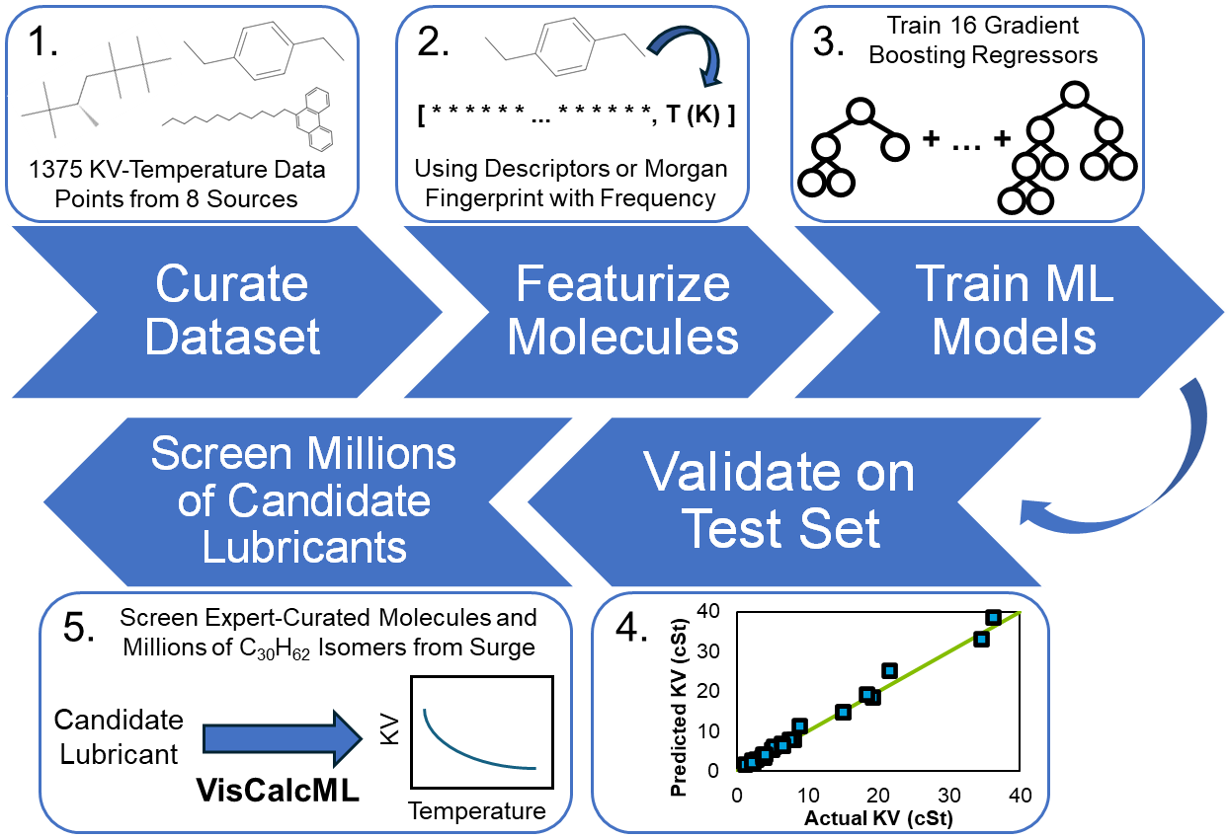
Figure 1. Illustration of VIsCalcML development workflow

- Methods
Dataset curation. 1403 empirical KV-temperature measurements from 406 unique hydrocarbons were curated from 8 data sources in the literature.[ref. datasets 1-8] Our dataset consisted of C₅ to C₅₀ molecules with molecular weights ranging from 68.1 g/mol to 702.8 g/mol. KV measurements were taken at atmospheric pressure and at temperatures ranging from 0 ° C to 100 ° C; KV measurements in the training set ranged from 0.30 cSt to 1.4 × 10⁴ cSt. Representative chemical structures are illustrated in Figure 2.
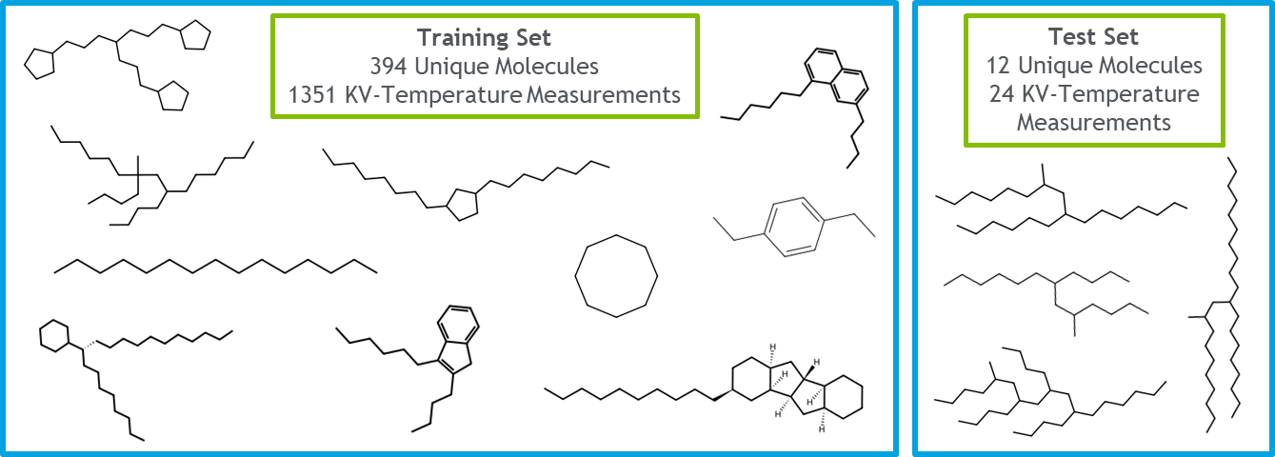
Figure 2. Overview of and representative chemical structures from the training set and test set for developing VisCalcML. For full list of SMILES comprising the training and test sets, see Supporting Information Table SX.
To generate a test set from this full dataset, we separated out data points from any molecules determined to be PAO-like. We chose to test our models on PAO-like molecules to validate their utility in the discovery of performant base oils, which are often PAO-like. PAO-like molecules also represent a different area of chemical space than our train set, which contained a diverse range of cyclic, highly branched, and linear hydrocarbons; thus, strong performance on our test and training sets validates that a model is not overfitted to a narrow region of the chemical space.
After separating PAO-like and non-PAO-like molecules, our test set consisted of 24 empirical KV-temperature measurements from 12 unique PAO-like molecules, and our training set consisted of 1379 empirical KV-temperature measurements from 394 unique non-PAO-like hydrocarbons. Since some data points in our training set had very high KV (as high as 1.4 * 10⁴ cSt), we removed the top 2% of data points by KV to ensure that our models were trained on data that was relevant to the development of base oils for lubricants. This yielded a training set of 1351 empirical KV-temperature measurements from 394 unique hydrocarbon molecules.
Cosmotherm-predicted KV of test set. The test set molecule SMILES were converted into 3D coordinate SDF files using Datawarrior.¹² The SDF files were then geometry optimized with the density functional theory program DMol3 with the PBE functional and dnp basis set.¹³ The surface charge profile for each molecule (as a .cosmo COSMO-RS file¹⁴) was imported into CosmoTherm software to predict dynamic viscosity and density at 40 and 100 °C. Kinematic viscosity was derived by dividing dynamic viscosity by density.
Generation of descriptors. To calculate molecular descriptors, molecules in our dataset were first converted to universal force field-optimized 3D coordinate SDF files using RDKit.¹⁵ Then, the community-maintained version of Mordred descriptor calculator was used to generate 2-D and 3-D descriptors for molecules in our dataset.¹⁶ 2-D descriptors only consider the connectivity of atoms in a molecule, while 3-D descriptors consider the 3-D coordinates of each non-hydrogen atom in a molecule. Finally, we removed any descriptors that could not be calculated for all molecules. This can occur, for example, when the denominator of a descriptor is equal to zero.

Generation of molecular fingerprints. Many types of molecular fingerprinting schemes have been developed.¹⁷ Herein we generate Morgan fingerprints¹⁸ with frequency (radius = 4) for each molecule in our dataset using RDKit. Morgan fingerprints with frequency are a vector representation for molecules, wherein each component of the vector indicates the frequency (number of occurrences) of a chemical substructure within a given molecule. Morgan fingerprints with frequency have been previously used for various cheminformatics tasks such as drug discovery¹⁹ and prediction of T_{g} for polymers.²⁰ For comparison, both chiral and non-chiral fingerprints were considered, in case different diastereomers of PAO could be distinguished.

Enumeration of C₃₀H₆₂ isomers using Surge v1.0. The number of all possible C₃₀H₆₂ steric isomers has been mathematically determined by Pólya’s enumeration theorem and Fujita’s proligand method to be 182896187256.^{4,21} Because enantiomers must possess identical viscosity, only one of each enantiomeric pair must be analyzed, reducing the number of isomers to consider down to 91449677878. For computational tractability, the isomer chemical space can be further pared down to 4111846763 constitutional isomers, where only one molecule is considered per set of diastereomers. To generate SMILES notation for all the constitutional isomers of C₃₀H₆₂ , the program Surge v1.0 was used,²² which finished after ~14 days running on a single core of a 2.0 GHz processor. The resulting output text file, containing one SMILES per line, was over 200 gigabytes in size. To analyze these SMILES, we first randomly selected a subset of SMILES from this output file to ensure computational feasibility. This subset comprised 10% of all SMILES in the original file. Then, we used our top-performing ML model to predict KV for this subset of molecules at a range of temperatures (20 °C, 40 °C, 60 °C, 80 °C, and 100 °C) to identify promising candidate base oils for future synthesis and characterization.

Feature selection.
In addition to the four different molecular features described earlier (fingerprints, chiral fingerprints, descriptors, 3D descriptors), we applied four different mathematical transformations to KV ( KV, ln⁡(KV), log10(KV), and no transformation). This yielded 16 unique feature-target combinations which we used to train 16 machine learning models.
Because each of our four feature sets contained over 1000 features each, feature selection was required to ensure computational feasibility. To prevent human bias from unduly influencing our feature choices, we used a LASSO regression to select features for each of the 16 feature-target combinations. Briefly, for each feature-target combination, the 10-fold cross-validated mean squared error (MSE) across the training set was calculated for 41 values of α, the regularization parameter of LASSO, evenly log-spaced from 10⁻⁴ to 10⁰. Cross-validation folds were randomly generated; since some molecules had multiple KV-temperature measurements, care was taken to ensure that each molecule was only present in a single fold. The optimal value of α was selected as the maximum value of α for which the LASSO’s cross-validated mean squared error was within 1 standard deviation of the minimum (best-performing LASSO model), following the recommendation of Hastie et al.²³ Using this optimal α, all features with coefficients greater than the threshold (10⁻⁵) were selected for each of our 16 feature-target combinations.
Machine learning model development.
Once we selected features for our 16 feature-target combinations, we set out to train a total of 16 gradient boosting regressor models – 1 for each feature-target combination. Gradient boosting regressor was selected as our model of choice because they perform favorably on tabular data and have been applied successfully in the past to various molecular property prediction tasks.²⁴ Gradient boosting regressor models were implemented in Python using the Scikit-Learn package.²⁵
To determine optimal hyperparameters for these 16 models, we performed 500 iterations of hyperparameter optimization with nested 10-fold cross-validation using the “bayes_opt” Python package.²⁶ The following variables were optimized within the following ranges: “max_depth” [0,1], “subsample” [-0.5,1], “learning_rate” [10⁻⁴, 10⁻¹], “n_estimators” [10², 10^{3.5}]. Cross-validation folds were randomly generated; since some molecules had multiple KV-temperature measurements, our code was implemented such that each molecule was only present in a single fold.
Importantly, our optimization objective during Bayesian optimization was to minimize the mean squared error of our model-predicted KV_pred vs KV_actual in units of cSt, regardless of which mathematical transformation had previously been applied to KV. For example, if the natural logarithm of KV was selected, the model would predict lnKV; however, the optimization objective would still be to minimize the mean squared error of KV_pred vs KV_actual (cSt), shown below.
minimize( MSE elnKV_pred, elnKV_actual )
Once optimal hyperparameters were selected for each of the 16 feature-target combinations, non-nested cross-validation was performed to determine the relative performance of each of these models. The model with the lowest cross-validated error was selected as our winning model and was used in further experiments.

- Results
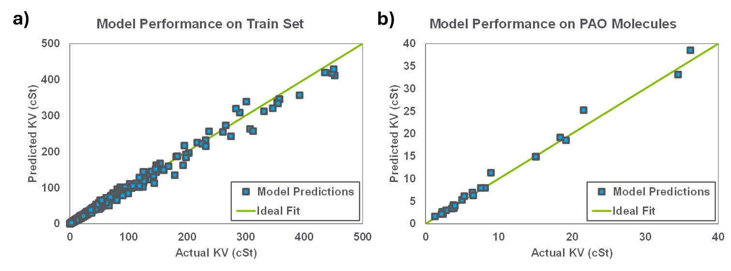
Figure 3. ML model performance on (a) training set and (b) test set of PAO-like molecules.

Our model predicts that comparing hydrocarbons of equal molecular weight, greater branching results in lower viscosity. This is in contrast to results from NEMD simulations,^{1b}

A common industrial metric to judge a base oil’s KV-temperature relation is viscosity index (VI), defined by the American Society for Testing and Materials (ASTM) D 2270 standard,{, 2003 #429} which is derived from KV⁴⁰ and KV¹⁰⁰. Higher VI corresponds to more consistent KV across this range of temperatures. VI derived from VisCalcML-predicted KV40 and KV100 did not have good correlation with VI calculated from experimental KV data (Figure X). This is expected in part, as the formula for VI is highly non-linear. Previous studies using molecular dynamics-informed machine learning also noted poor correlation between predicted and experimental VI.^{5i} Rather than targeting KV and then indirectly obtaining VI, future ML models may find more success directly targeting VI. Nasab and coworkers have used ML to directly predict VI and pour point of ester base oils with moderate success.²⁷ While non-equilibrium molecular dynamics prediction of VI has had some success up to C20,^{1b,28} such simulations remain too computationally expensive to evaluate wider sets of larger molecules.

Among the many isomers of C₃₀H₆₂, which are ideal base stock molecules exhibiting low KV40? The program Surge v1.0²² was utilized to enumerate the constitutional isomers of C₃₀H₆₂ (wherein a set of stereoisomers are counted as one constitutional isomer). 5% of these isomers were randomly selected, and KV⁴⁰ [[and KV¹⁰⁰ , necessary or redundant?]] predicted with VisCalcML (Figure X, scatterplot). The KV⁴⁰ for the C₃₀H₆₂ isomers are distributed around x.x cSt, but notably some isomers have KV40 as low as x.x cSt. One such isomer, [insert full chemical name], is illustrated in Figure X, containing Z quaternary carbons. Conventional PAOs and m-PAOs do not contain quaternary carbons.² While quaternary carbons in oils have been correlated with worse biodegradability,²⁹ and synthetic methods to economically produce quaternary carbon-containing synthetic oils are under-developed, one study did find that 1-decene oligomers containing a single quaternary carbon exhibited superior low-temperature fluidity and VI compared to conventional 1-decene-derived PAOs.³⁰

Note molecule(s) with lowest and highest KV⁴⁰, KV¹⁰⁰, VI
- Compare with m-PAO
- Compare with 3-PAO isomers produced by selectively by Ti and Cr catalysts.
PAOs are derived from oligomerization of readily available linear alpha olefins (LAOs), whereas the majority of all C₃₀H₆₂ isomers do not have feasible synthetic strategies. To focus on more reasonable structures, a set of C28-C32 molecules were developed using chemical intuition (Figure X), and KV was predicted for molecules M-N at a range of temperatures ( 20 °C, 40 °C, 60 °C, 80 °C, and 100 °C ). (Figure X, scatterplot wherein the various points are labeled and color-coded by family). Molecules M-N are diastereomers of the m-PAO C10 trimer, which could, in principle, be synthesized by choice of an appropriate metallocene catalyst.{Kaminsky, 2004 #435} Note that most PAO research does not distinguish between the diastereomeric isomers.

Molecules M-N are products of metallocene-catalyzed oligomerization of non-C10 LAOs and subsequent hydrogenation; note that 1-octene-based m-PAOs have been commercialized by Chevron as SynFluid mPAOs in higher viscosity grades (65-150 cSt). M-N have been reported as products of (non-metallocene) selective 1-decene trimerization catalysts and hydrogenation.[ref] Polyalkylbenzenes M-N could be alkylation products derived from benzene and LAOs, and polyalkylcyclohexanes M-N could be obtained by hydrogenation thereof. Pentaalkylcycloalkanes M-N are related to Nye Lubricants’s line of commercially available multiply alkylated cyclopentanes (MACs). The full results of this virtual screen are available in the Supporting Information, Table SX.
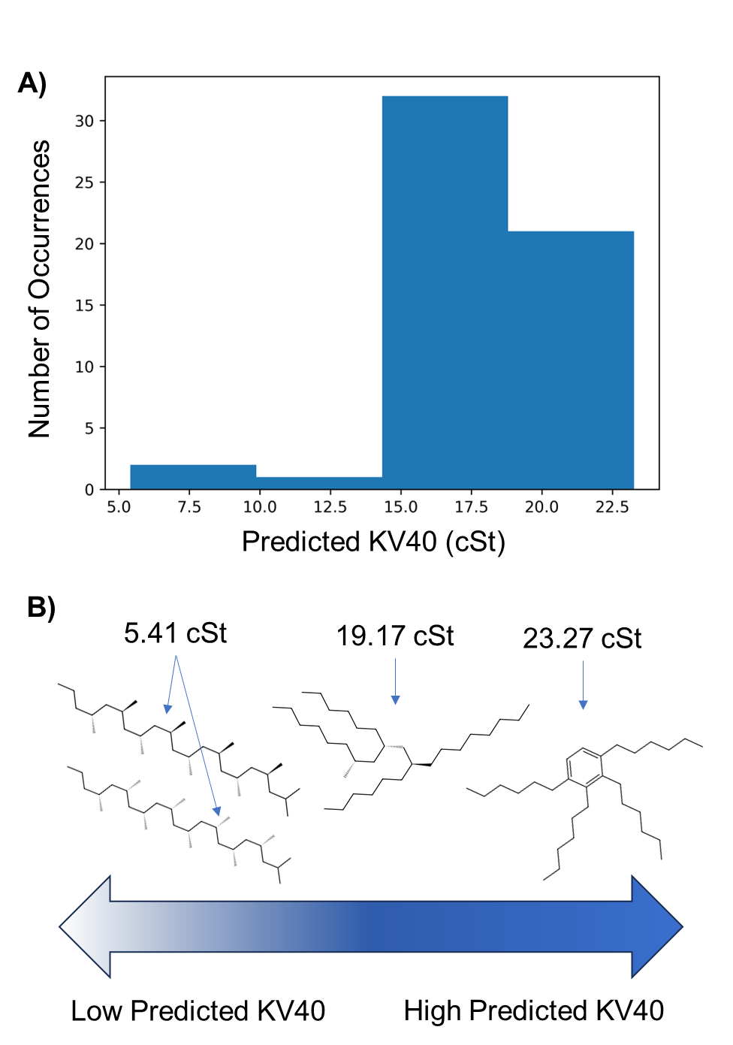
Figure 5. (A) Histogram of VisCalcML-predicted KV40 for expert-curated C₂₈₋₃₂ molecules; (B) example chemical structures from expert-curated C₃₀ set and their predicted KV40

Base oil candidate X could in principle be synthesized via propylene oligomerization to form a 10-mer. However, most olefin oligomerization catalysts produce a Schulz-Flory distribution of products containing minimal 10-mer; a minority of catalysts can selectively dimerize, trimerize, or tetramerize olefins.[reviews by Small, Gibson, etc.] Significant advances in catalyst design would be required to obtain significant fractions of a propylene 10-mer. Alternatively, X could be obtained via breakdown of waste polypropylene. Synthetic oils have been derived from waste plastics, primarily polyethylene.³¹ We hope this report inspires collaboration between researchers studying plastics valorization and tribologists.

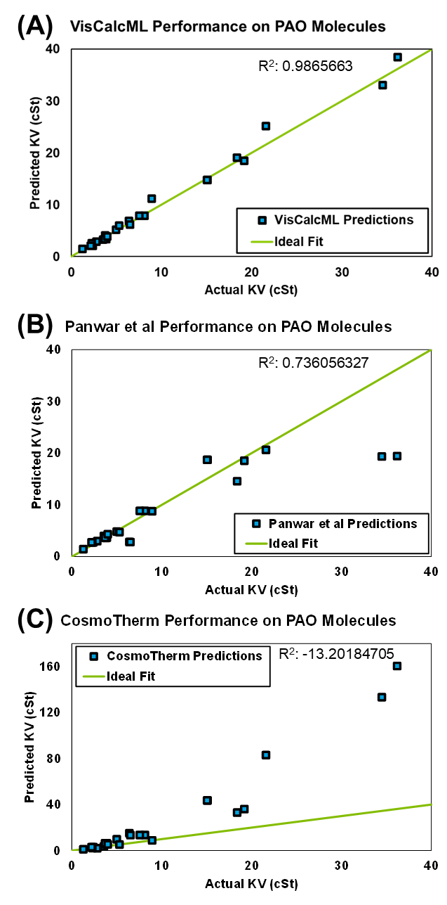
Figure 4. Performance comparison between (a) VisCalcML (b) Panwar’s model, and (c) CosmoTherm at predicting KV of PAO-like molecules of test set.

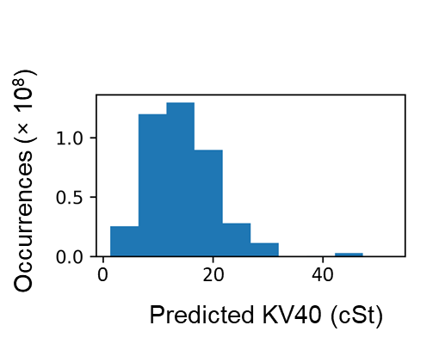
Figure 6.

- Conclusion

References
(1) (a) Lillard, J. G.; Jones, W. C.; Anderson, J. A. "Molecular Structure and Properties of Lubricating Oil Components." Industrial & Engineering Chemistry 1952, 44, 2623(b) Kioupis, L. I.; Maginn, E. J. "Molecular Simulation of Poly-α-olefin Synthetic Lubricants: Impact of Molecular Architecture on Performance Properties." J. Phys. Chem. B 1999, 103, 10781.
(2) Kapur, G. S.; Sarpal, A. S.; Sarin, R.; Jain, S. K.; Srivastava, S. P.; Bhatnagar, A. K. "Detailed characterisation of polyalphaolefins and their branched structures using multi-pulse NMR techniques." Journal of Synthetic Lubrication 1998, 15, 177.
(3) Nifant’ev, I. E.; Vinogradov, A. A.; Vinogradov, A. A.; Sedov, I. V.; Dorokhov, V. G.; Lyadov, A. S.; Ivchenko, P. V. "Structurally uniform 1-hexene, 1-octene, and 1-decene oligomers: Zirconocene/MAO-catalyzed preparation, characterization, and prospects of their use as low-viscosity low-temperature oil base stocks." Applied Catalysis A: General 2018, 549, 40.
(4) (a) Fujita, S. "Alkanes as Stereoisomers. Enumeration by the Combination of Two Dichotomies for Three-Dimensional Trees." MATCH Commun. Math. Comput. Chem. 2007, 57, 299(b) Fujita, S. "Numbers of Alkanes and Monosubstituted Alkanes. A Long-Standing Interdisciplinary Problem over 130 Years." Bulletin of The Chemical Society of Japan - BULL CHEM SOC JPN 2010, 83, 1.
(5) (a) Padilla, P.; Toxvaerd, S. "Self‐diffusion in n‐alkane fluid models." J. Chem. Phys. 1991, 94, 5650(b) Cui, S. T.; Gupta, S. A.; Cummings, P. T.; Cochran, H. D. "Molecular dynamics simulations of the rheology of normal decane, hexadecane, and tetracosane." J. Chem. Phys. 1996, 105, 1214(c) Cui, S. T.; Cummings, P. T.; Cochran, H. D.; Moore, J. D.; Gupta, S. A. "Nonequilibrium Molecular Dynamics Simulation of the Rheology of Linear and Branched Alkanes." Int. J. Thermophys. 1998, 19, 449(d) Martin, M. G.; Siepmann, J. I. "Novel Configurational-Bias Monte Carlo Method for Branched Molecules. Transferable Potentials for Phase Equilibria. 2. United-Atom Description of Branched Alkanes." J. Phys. Chem. B 1999, 103, 4508(e) Chang, J.; Sandler, S. I. "Interatomic Lennard-Jones potentials of linear and branched alkanes calibrated by Gibbs ensemble simulations for vapor-liquid equilibria." J. Chem. Phys. 2004, 121, 7474(f) Tartaglino, U.; Sivebaek, I. M.; Persson, B. N. J.; Tosatti, E. "Impact of molecular structure on the lubricant squeeze-out between curved surfaces with long range elasticity." J. Chem. Phys. 2006, 125(g) Liu, P.; Yu, H.; Ren, N.; Lockwood, F. E.; Wang, Q. J. "Pressure–Viscosity Coefficient of Hydrocarbon Base Oil through Molecular Dynamics Simulations." Tribology Letters 2015, 60, 34(h) Panwar, P.; Yang, Q.; Martini, A. "Temperature-Dependent Density and Viscosity Prediction for Hydrocarbons: Machine Learning and Molecular Dynamics Simulations." Journal of Chemical Information and Modeling 2023(i) Kajita, S.; Kinjo, T.; Nishi, T. "Autonomous molecular design by Monte-Carlo tree search and rapid evaluations using molecular dynamics simulations." Communications Physics 2020, 3, 77.
(6) Cardona, L. F.; Forero, L. A.; Velásquez, J. A. "Extension of a Group Contribution Method to Predict Viscosity Based on Momentum Transport Theory Using a Modified Peng–Robinson EoS." Industrial & Engineering Chemistry Research 2021, 60, 14903.
(7) Saldana, D. A.; Starck, L.; Mougin, P.; Rousseau, B.; Ferrando, N.; Creton, B. "Prediction of Density and Viscosity of Biofuel Compounds Using Machine Learning Methods." Energy & Fuels 2012, 26, 2416.
(8) (a) Paduszyński, K.; Domańska, U. "Viscosity of Ionic Liquids: An Extensive Database and a New Group Contribution Model Based on a Feed-Forward Artificial Neural Network." Journal of Chemical Information and Modeling 2014, 54, 1311(b) Beckner, W.; Mao, C. M.; Pfaendtner, J. "Statistical models are able to predict ionic liquid viscosity across a wide range of chemical functionalities and experimental conditions." Molecular Systems Design & Engineering 2018, 3, 253.
(9) Avula, N. V. S.; Veesam, S. K.; Behera, S.; Balasubramanian, S. "Building robust machine learning models for small chemical science data: the case of shear viscosity of fluids." Machine Learning: Science and Technology 2022, 3, 045032.
(10) Santak, P.; Conduit, G. "Predicting physical properties of alkanes with neural networks." Fluid Phase Equilibria 2019, 501, 112259.
(11) Yap, C. W. "PaDEL-descriptor: An open source software to calculate molecular descriptors and fingerprints." J. Comput. Chem. 2011, 32, 1466.
(12) Sander, T.; Freyss, J.; von Korff, M.; Rufener, C. "DataWarrior: An Open-Source Program For Chemistry Aware Data Visualization And Analysis." Journal of Chemical Information and Modeling 2015, 55, 460.
(13) (a) Delley, B. "From molecules to solids with the DMol3 approach." J. Chem. Phys. 2000, 113, 7756(b) Perdew, J. P.; Burke, K.; Ernzerhof, M. "Generalized Gradient Approximation Made Simple." Phys. Rev. Lett. 1996, 77, 3865.
(14) Klamt, A. "Conductor-like Screening Model for Real Solvents: A New Approach to the Quantitative Calculation of Solvation Phenomena." The Journal of Physical Chemistry 1995, 99, 2224.
(15) “RDKit: Open-source cheminformatics.,” https://www.rdkit.org (accessed
(16) (a) Moriwaki, H.; Tian, Y.-S.; Kawashita, N.; Takagi, T. "Mordred: a molecular descriptor calculator." Journal of Cheminformatics 2018, 10, 4(b) “mordredcommunity: Community maintained version of mordred molecular descriptor calculator,” https://github.com/JacksonBurns/mordred-community (accessed
(17) Boldini, D.; Ballabio, D.; Consonni, V.; Todeschini, R.; Grisoni, F.; Sieber, S. A. "Effectiveness of molecular fingerprints for exploring the chemical space of natural products." Journal of Cheminformatics 2024, 16, 35.
(18) (a) Morgan, H. L. "The Generation of a Unique Machine Description for Chemical Structures-A Technique Developed at Chemical Abstracts Service." Journal of Chemical Documentation 1965, 5, 107(b) Rogers, D.; Hahn, M. "Extended-Connectivity Fingerprints." Journal of Chemical Information and Modeling 2010, 50, 742.
(19) Zhou, H.; Skolnick, J. "Utility of the Morgan Fingerprint in Structure-Based Virtual Ligand Screening." J. Phys. Chem. B 2024.
(20) Tao, L.; Varshney, V.; Li, Y. "Benchmarking Machine Learning Models for Polymer Informatics: An Example of Glass Transition Temperature." Journal of Chemical Information and Modeling 2021, 61, 5395.
(21) Pólya, G. "Kombinatorische Anzahlbestimmungen für Gruppen, Graphen und chemische Verbindungen." Acta Mathematica 1937, 68, 145.
(22) McKay, B. D.; Yirik, M. A.; Steinbeck, C. "Surge: a fast open-source chemical graph generator." Journal of Cheminformatics 2022, 14, 24.
(23) Hastie, T.; Tibshirani, R.; Friedman, J. In The Elements of Statistical Learning: Data Mining, Inference, and Prediction; Springer New York: New York, NY, 2009.
(24) Ke, G.; Meng, Q.; Finley, T.; Wang, T.; Chen, W.; Ma, W.; Ye, Q.; Liu, T.-Y. Advances in Neural Information Processing Systems, 2017; p 3149.
(25) Pedregosa, F.; Varoquaux, G.; Gramfort, A.; Michel, V.; Thirion, B.; Grisel, O.; Blondel, M.; Prettenhofer, P.; Weiss, R.; Dubourg, V.; Vanderplas, J.; Passos, A.; Cournapeau, D.; Brucher, M.; Perrot, M.; Duchesnay, É. "Scikit-learn: Machine Learning in Python." J. Mach. Learn. Res. 2011, 12, 2825.
(26) Nogueira, F. “{Bayesian Optimization}: Open source constrained global optimization tool for {Python},” https://github.com/bayesian-optimization/BayesianOptimization (accessed
(27) Nasab, S. G.; Semnani, A.; Marini, F.; Biancolillo, A. "Prediction of viscosity index and pour point in ester lubricants using quantitative structure-property relationship (QSPR)." Chemometrics and Intelligent Laboratory Systems 2018, 183, 59.
(28) Mathas, D.; Holweger, W.; Wolf, M.; Bohnert, C.; Bakolas, V.; Procelewska, J.; Wang, L.; Bair, S.; Skylaris, C.-K. "Evaluation of Methods for Viscosity Simulations of Lubricants at Different Temperatures and Pressures: A Case Study on PAO-2." Tribology Transactions 2021, 64, 1138.
(29) Solano-Serena, F.; Marchal, R.; Casarégola, S.; Vasnier, C.; Lebeault, J. M.; Vandecasteele, J. P. "A Mycobacterium strain with extended capacities for degradation of gasoline hydrocarbons." Appl. Environ. Microbiol. 2000, 66, 2392.
(30) Zhao, R.; Mi, P.; Xu, S.; Dong, S. "Structure and Properties of Poly-α-olefins Containing Quaternary Carbon Centers." ACS Omega 2020, 5, 9142.
(31) (a) Hackler, R. A.; Vyavhare, K.; Kennedy, R. M.; Celik, G.; Kanbur, U.; Griffin, P. J.; Sadow, A. D.; Zang, G.; Elgowainy, A.; Sun, P.; Poeppelmeier, K. R.; Erdemir, A.; Delferro, M. "Synthetic Lubricants Derived from Plastic Waste and their Tribological Performance." ChemSusChem 2021, 14, 4181(b) Zeng, M.; Lee, Y.-H.; Strong, G.; LaPointe, A. M.; Kocen, A. L.; Qu, Z.; Coates, G. W.; Scott, S. L.; Abu-Omar, M. M. "Chemical Upcycling of Polyethylene to Value-Added α,ω-Divinyl-Functionalized Oligomers." ACS Sustainable Chemistry & Engineering 2021, 9, 13926(c) Liu, S.; Kots, P. A.; Vance, B. C.; Danielson, A.; Vlachos, D. G. "Plastic waste to fuels by hydrocracking at mild conditions." Science Advances 2021, 7, eabf8283.

Journal | Impact Factor
Fuel (LaTeX): | 7.4
Energy & Fuels | 5.3
Journal of Chemical Information and Modelling | 5.6
Industrial & Engineering Chemistry Research | 4.2
JACS Au | 8.0
ACS Omega | 4.1

